Getting started with TARDIS (Temporal Analysis of Relative Distances)

# Installation

Run TARDIS_installer and follow the prompts. TARDIS will be installed in C:/Program Files/Bonn University/TARDIS, and installation will take approximately 5-10 minutes.

Alternatively, download the files contained on the TARDIS_public github page, go to the main folder in your MATLAB environment, and run TARDIS_app.mlapp.

Alternatively, use TARDIS in a script-like manner – read Main/Call_TARDIS_example.m for information

The software has been tested on Windows 10 machines, and on MATLAB R2021b.

CC BY-NC-SA 4.0 licenced

# UI overview and getting started guide

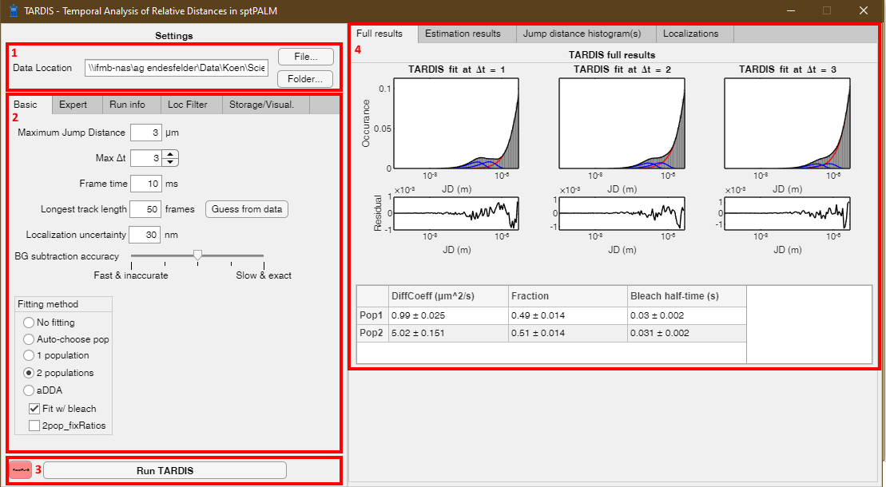

After opening the UI for the first time, a screen similar to this will appear (without results). To start an analysis, briefly follow the following steps. A succinct explanation of all settings is present in chapter 4.

1. Choose location for the data.
   * The data should be either a **.csv containing ThunderSTORM** output (with at least column headings ‘frame’, ‘x [nm]’ and ‘y [nm]’), or a **.mat file containing a ‘pos’ array** with at least 3 columns (1st column frame, 2nd column x position, 3rd column y position; positions should be in meter units).
   * You can find a file with the ‘File…’ button, or alternatively do batch-analysis on a whole folder via the ‘Folder…’ button.
2. Choose the correct settings
   * There are four tabs at the top. Only the ‘Basic’ settings are normally required to be changed between experiments, as these have to do with experiment-dependant settings. The ‘Expert’ tab is normally not required, but contains more in-depth settings to change. The ‘Run info’ tab will give information during a fitting procedure. The ‘Loc Filter’ tab can be used to filter localizations based on headings (if a ThunderSTORM .csv file is loaded) The ‘Visualisation’ tab provides some options for visualisation, and also gives the option to visualise previously generated output of TARDIS.
     1. **Note that you can hover over the different settings with the mouse to get a brief overview of the parameter.**
   * Settings will be stored between uses of TARDIS.
3. Run TARDIS
   * As soon as analysis starts, the results-section will be cleared, and will show the localizations found in the loaded file. This can be a quick check that the correct file is chosen.
   * While TARDIS is running, the ‘Run info’ tab will show info of the fitting procedure.
   * After TARDIS has been completed, the output will be presented in the results-section on the right.
   * Additionally, TARDIS result data will be stored in a ‘TARDIS_Results’ subfolder at the location of the data.
     1. Briefly, 4 outputs are generated, depending on the settings in the ‘Storage/Visual.’ tab. The full TARDIS visualisation will be stored as a .png and a .svg. Additionally, a JSON file with all quantitative fit parameters and settings will be stored. Lastly, an elaborate .mat file will be stored that contains all information of the TARDIS run.
4. Review results
   * The result-section is subdivided in four parts.
     1. The ‘Full results’ tab will provide the final TARDIS results, and gives both a visual fit (top), and a quantitative result of the fitting parameters (botton).
     2. The ‘Estimation results’ tab will provide some details on a first, estimative fit. This estimation is only used to obtain starting parameters for the final fit to prevent fitting local maxima.
     3. The ‘Jump distance histogram(s)’ tab will give a showcase of the jump distance histogram (in linear and logarithmic scaling) of the trajectory information.
     4. The ‘Localizations’ tab provides an overview of the localizations loaded in the data, and can act as a quick check that the data is loaded correctly.

# Example datasets

Example datasets are provided in Example_data, the same datasets as .mat files and as .csv files. They can be run in TARDIS as described above (with loc_unc 30 nm). It is recommended to start running the Single_Population_1um2s_lowDensity.mat dataset, where a single population with 1 um2/s diffusion and 0.03 second (assuming 10 ms frame-time) bleach-time will be obtained. Analysing this dataset (without using the ‘Wilcoxon approximation’ or ‘Guess track length from data’) will take 10-30 seconds.

# All settings

# Basic

Generally, these are the settings that should be reviewed for each experiment.

* **Maximum jump distance** is a limit on how ‘far’ TARDIS should perform the analysis. This value should be higher than the largest expected jump distance at the largest Δt used, and it is recommended to put this at approximately 1.5 times the largest jump distance. There is no algorithmic reason to keep this value low, but lower values speeds up the analysis.
* **Max Δt** dictates which Δt-bins (in frames) will be used. In the example screen above, a Δt of 3 was used. It is unwise to make this higher than the expected mean maximum length of the tracks. Normally, a value of 2-4 works best.
* **Frame time** is the frame time of the experiment, and is used to quantify the diffusion coefficient.
* **Longest track length** is an estimation of the longest track that will be present in the experiment. More precisely, this is the Δt at which the ‘background-only’ determination will start. It is better to estimate this a little too high than too low. The ‘Guess from data’ button uses a statistical test to obtain this directly from the data (but can be very slow for large datasets)
* **Localization uncertainty** is the (expected) localization uncertainty throughout the experiment.
* **BG subtraction accuracy** indicates how many Δt-bins (starting at the ‘longest track length’) will be used. More bins will give smoother results, but also longer analysis times. This scale is logarithmic, and scales from 1 Δt to 50 Δt.
* **Fitting method** determines which analytical formula will be fitted. TARDIS currently supports single- and double-populations fit, as well as analytical diffusion distribution analysis (aDDA). If aDDA is chosen, a new sub-menu for aDDA will be opened for aDDA-specific settings, such as number of species and possible cellular confinement. Alternatively, no fitting or an automatic selection of 1 or 2 populations can be used. Finally, it provides checkboxes to fit with an exponential bleach-decay parameter (rather than estimating the background fraction for all Δt), and to fix the ratio of two populations between all Δt’s.

## Expert

Keep in mind that these settings are normally not the reason for unsuccessful TARDIS results, but if you know what you’re doing, feel free to change these settings.

* The **Fitting Constraints** settings will alter the start points (and lower/upper bounds) of the parameters used in the estimation fit, or in the full fit if the estimation fit is not used. They should be entered as follows:
  + A random value can be entered as [A-B], where the value is randomly chosen between A and B.
  + For 1 population: [Diffusion Coefficient], in µm2/s
  + For 2 populations: [Diffusion Coefficient 1 [SPACE] Diffusion Coefficient 2 [SPACE] ratio] ; diffusion coefficients in µm2/s, and the ratio is the 1:X ratio of the 2 populations (i.e. a ratio value of 1 means a 1:1 ratio of the populations, and thus a 50%:50% ratio. A ratio value of 2 means a 1:2 ratio, and thus a 33%:66% ratio).
  + For aDDA: [kon [SPACE] koff [SPACE] Diffusion Coefficient of the free population]
* The **Perform estimation fit** checkbox indicates whether or not an estimation fit will be performed. This is normally not required, but could prevent fitting of local minima. Disabling it will speed up the fitting procedure.
* **Number of BG bins** dictates at how many *x-*positions TARDIS will store a BG value. For the downstream analysis, TARDIS will perform interpolation between these positions. Normally, changing this value does not substantially change the results, but large JD differences between single bins can decrease fit accuracy.
* **BG subtraction interpolation** can be linear or logarithmic, and it determines whether the BG bins described above will be taken on a linear or a logarithmic scale. As long as enough BG bins are used, changing this has little effect on the TARDIS fit.
* **Startpoint BG (ratio of max JD)** requires a value between 0 and <1, and is used for the estimation fit as a startpoint on where *only background* is expected. For example, if a max jump distance (Basic settings) of 3 µm is chosen, and this setting is 0.66, it means that for the estimation fit, TARDIS assumes that everything with a JD higher than 0.66∙3 = 2 µm will not contain jumping distances corresponding to signal anymore.
* **Noise density** is a value of the expected localizations that are not trajectory, but rather single-frame-duration, noisy particles. This value is only used to approximate the blinking probability of the dataset.
* **Verbose**, when selected, will provide thorough information on the fit in the main MATLAB window.
* **Strobo correction** allows for correction of (lack of) stroboscopic illumination on obtained Diffusion coefficient, following Berglund et al., 2010.

## Run info

This tab will simply provide information on the fit while TARDIS is performing the fit. It might be useful to keep an eye open on this, because it will also report possible errors.

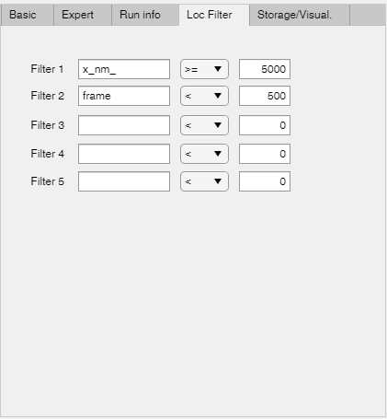

## Loc Filter

In this tab, you can filter localizations based on one of there headers. This example (left) is provided for a ThunderSTORM file. Please note that spaces need to be removed and double-quotes are changed to underscores, so [x “nm”] is changed to [x_nm_].

## Storage/visualisation

This tab provides options for storage and visualisation. Select which files/images to store after a fit, and/or open the storage folder with the button. Additionally, there is an single option whether it should be scaled linearly or logarithmically. Note that this does not influence the fitting at all.

Additionally, previously obtained TARDIS results (stored in *_TARDISresult.mat files) can be loaded at the bottom, and be visualised.